Saskatchewan Facility Designation Regulations (v1.0)

Authors
- Puneet Kapur – Physician Lead for Virtual Physician Program

Preamble
- GOS = Government of Saskatchewan
- From the provincial “Facility Designation Regulations” document following version

- Document can be downloaded from here.
- List of GOS legislation in PDF formats can be found at the Office of the Kings Printer

Executive Summary
The GOS lists 8 categories of facilities of which category 4 relates to hospital. The hospitals are further organized into 6 subcategories.
All subcategories of hospitals (except for field hospitals) “must provide … basic radiography and laboratory services”. There is no part of the “Facility Designation Regulations” that refers to radiography being an optional service at any time.

Categories of facilities and subcategories of hospitals
The GOS definitions at the top of the document define the following
- Total of EIGHT CATEGORIES of facilities
- Total of SIX SUB-CATEGORIES of hospitals
Facility List | Orginal Image from GOS document
- Addiction Treatment Center  - Complex Care Center  - Health Center  - Hospital  - Mental Health Center  - Residential Treatment Center  - Special Care Home  - Urgent Care Center | 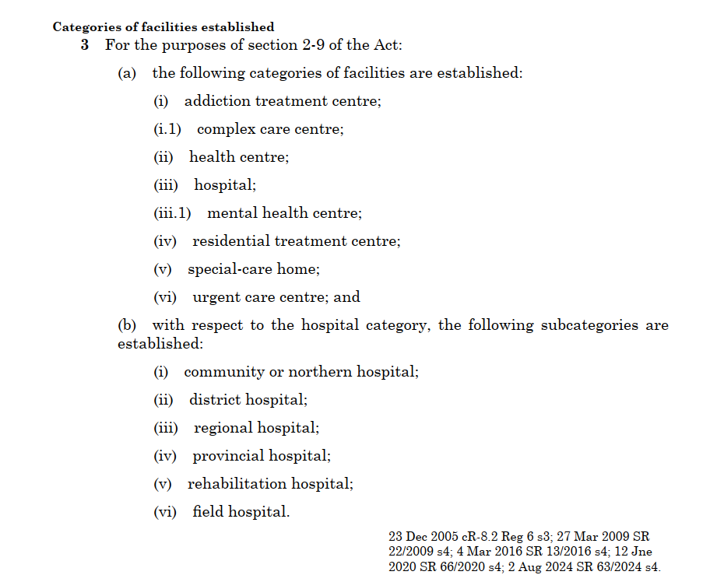
Hospital List | Origingal Image from GOS document
- Community or Northern Hospital
- District Hospital
- Regional Hospital
- Provincial Hospital
- Rehabilitation Hospital
- Field hospital

Specific services in each facility

Type of Facility | Services as per GOS
Facility Category 1  Addiction Treatment | If a facility or part of a facility is designated as an addiction treatment centre, it  must provide to individuals who are affected by abuse of, or dependence on, alcohol, a  drug or another substance one or more of the following services on a residential basis:  (a) personal care;  (b) alcohol, drug or substance abuse or addiction education services;  (c) alcohol, drug or substance abuse or addiction assessment services;  (d) detoxification services;  (e) alcohol, drug or substance abuse or addiction treatment services;  (f) rehabilitation services.
Facility Category 2  Complex Care Center | If a facility or part of a facility is designated as a complex care centre:  (a) it must provide:  (i) complex care;  (ii) personal care or nursing care to children who reside in the facility on a temporary basis and are unable to care for themselves; and  (iii) respite care; and  (b) it may provide:  (i) rehabilitation services;  (ii) health assessment services;  (iii) education and training services;  (iv) counselling services;  (v) therapy services;  (vi) referral services; and  (vii) health promotion services.
Facility Category 3  Health Center | If a facility or part of a facility is designated as a health centre, it must provide  one or more of the following services:  (a) physician services;  (a.1) physician assistant services;  (b) registered nurse or nurse practitioner services;  (c) basic radiography and laboratory services;  (d) emergency stabilization services;  (e) convalescent care and palliative care;  (f) long-term care;  (g) health assessment and screening services;  (h) counselling services;  (i) therapy services;  (j) referral services;  (k) health education services;  (l) health promotion services;  (m) disease and injury prevention services;  (n) chronic disease management services;  (o) disability management services.
Facility Category 4  Hospital | SEE HOSPITAL SUBCATEGORIES BELOW
Facility Category 5  Mental Health Center | If a facility or part of a facility is designated as a mental health centre:  (a) it must provide the following services to in-patients and out-patients:  (i) physician services;  (ii) specialty physician services in the area of psychiatry;  (iii) registered nurse and registered psychiatric nurse services;  (iv) mental health services;  (v) emergency stabilization services;  (vi) observation and assessment services;  (vii) rehabilitation services; and  (b) it may provide the following services to in-patients and out-patients:  (i) physician assistant services;  (ii) nurse practitioner services;  (iii) any of the services mentioned in clauses 5(g) to (o).
Facility Category 6  Residential Treatment Center | If a facility or part of a facility is designated as a residential treatment centre, it must provide to individuals on a residential basis:  (a) mental health services;  (b) personal care services;  (c) rehabilitation services; and  (d) one or more of the services mentioned in clauses 5(g) to (o).
Facility Category 7  Special Care Home | If a facility or part of a facility is designated as a special-care home:  (a) it must provide personal care or nursing care to individuals who reside  in the facility on a temporary or permanent basis who are unable to care fully  for themselves and require care; and  (b) it may provide any of the following;  (i) convalescent care;  (ii) rehabilitation services;  (iii) palliative care;  (iv) respite care;  (v) day programming.
Facility Category 8  Urgent Care Center | If a facility or part of a facility is designated as an urgent care centre, it must provide one or more of the following services:  (a) physician services;  (b) registered nurse, registered psychiatric nurse or nurse practitioner  services;  (c) basic radiography and laboratory services;  (d) emergency stabilization services;  (e) episodic mental health and addiction services;  (f) counselling services;  (g) pharmacy services;  (h) episodic disease and injury services;  (i) episodic chronic disease services.

Subcategories of Hospitals

Subcategory 1  Community or Northern Hospital | If a facility or part of a facility is designated as a community or northern hospital:  (a) it must provide to in-patients and out-patients:  (i) medical services;  (ii) basic radiography and laboratory services;  (iii) emergency stabilization services;  (iv) observation and assessment services; and  (v) convalescent care and palliative care; and  (b) it may provide any of the following:  (i) out-patient surgical services;  (ii) obstetrical services;  (iii) services mentioned in clauses 5(f) to (o).
Subcategory 2  District Hospital | If a facility or part of a facility is designated as a district hospital:  (a) it must provide to in-patients and out-patients:  (i) medical services;  (ii) basic radiography and laboratory services;  (iii) emergency stabilization services;  (iv) observation and assessment services;  (v) convalescent care and palliative care; and  (vi) obstetrical services; and  (b) it may provide any of the following:  (i) surgical services;  (ii) services mentioned in clauses 5(f) to (o).
Subcategory 3  Regional Hospital | If a facility or part of a facility is designated as a regional hospital:  (a) it must provide to in-patients and out-patients:  (i) medical services;  (ii) basic radiography and laboratory services;  (iii) fluoroscopy and computerized tomography diagnostic services;  (iv) emergency stabilization services;  (v) observation and assessment services;  (vi) convalescent care and palliative care;  (vii) surgical services;  (viii) obstetrical services;  (ix) intensive care services; and  (x) specialty medical services in the areas of internal medicine, general surgery,  obstetrics and gynaecology; and  (b) it may provide any of the following:  (i) specialty medical services in areas including, but not limited to, orthopaedics,  ophthalmology, urology and otolaryngology;  (ii) rehabilitation services;  (iii) services mentioned in clauses 5(f) to (o).
Subcategory 4  Provincial Hospital | If a facility or part of a facility is designated as a provincial hospital:  (a) it must provide to in-patients and out-patients:  (i) medical services;  (ii) basic radiography and laboratory services;  (iii) fluoroscopy and computerized tomography diagnostic services;  (iv) emergency stabilization services;  (v) emergency and trauma services;  (vi) observation and assessment services;  (vii) convalescent care and palliative care;  (viii) surgical services; and  (ix) specialty medical services in the areas of internal medicine and general  surgery; and  (b) it may provide any of the following:  (i) interventional radiology, magnetic resonance imaging, nuclear medicine and  hemodynamic laboratory services;  (ii) intensive care services;  (iii) obstetrical and gynaecological services;  (iv) intensive neonatal and paediatric services;  (v) specialty and subspecialty medical services and surgical services;  (vi) rehabilitation services;  (vii) services mentioned in clauses 5(f) to (o).
Subcategory 5  Rehabilitation Hospital | If a facility or part of a facility is designated as a rehabilitation hospital, it must provide to in-patients and out-patients:  (a) rehabilitation services; and  (b) one or more of the services mentioned in clauses 5(f) to (o).
Subcategory 6  Field Hospital | If a facility or part of a facility is designated as a field hospital, it may provide to in-patients:  (a) medical services;  (b) basic radiography and laboratory services;  (c) emergency stabilization services;  (d) observation and assessment services;  (e) convalescent care and palliative care;  (f) services mentioned in clauses 5(f) to (j); and  (g) if the minister considers it necessary to do so in the public interest, any  other health services that the minister may order.  (2) If the minister issues an order pursuant to clause (1)(g), the minister shall  cause the order:  (a) to be published in the Gazette; and  (b) to be made public in any other manner the minister considers necessary,  including publishing it on the ministry’s website.

