# 

# KEEP CURRENT STATE (Audio First + Video on demand)

|  |  |  |
| --- | --- | --- |
|  | Win | Loss |
| Patients | 1. Faster visits without video. Less setup. Less technology overhead 2. Can still have video on demand | 1. Patient experience is just talking into a phone |
| Nurses | 1. Easy to use reliable phone / audio technology. Flat learning curve 2. Do not have to learn to use / setup / initiate video calls 3. Every call is recorded and stored at 811 4. Same call connects to 811 and then (without changing devices) connects through to MD 5. Physician orders and medication instructions are recorded and available for audit. This is how we overcome nursing concerns that there is no physician to ‘sign the orders’ | 1. They have to report any physical exam findings verbally if physician does not use video. 2. If video is required, it must be physician initiated |
| Physicians | 1. The virtual physician programs (811 and ER programs) have taken care of almost 50K patients using audio with excellent results. 2. Recorded audio calls are used to preform audits if there are questions about clinical care or adverse events | 1. None |
| Healthline | 1. The current Virtual Physician for ER technology builds atop similar ‘audio-only’ programs. Namely the Virtual physician for 811 and Healthline itself which is audio only. Common tools and common technology stack. | 1. None. Healthline has operated as audio only for 20 years. |

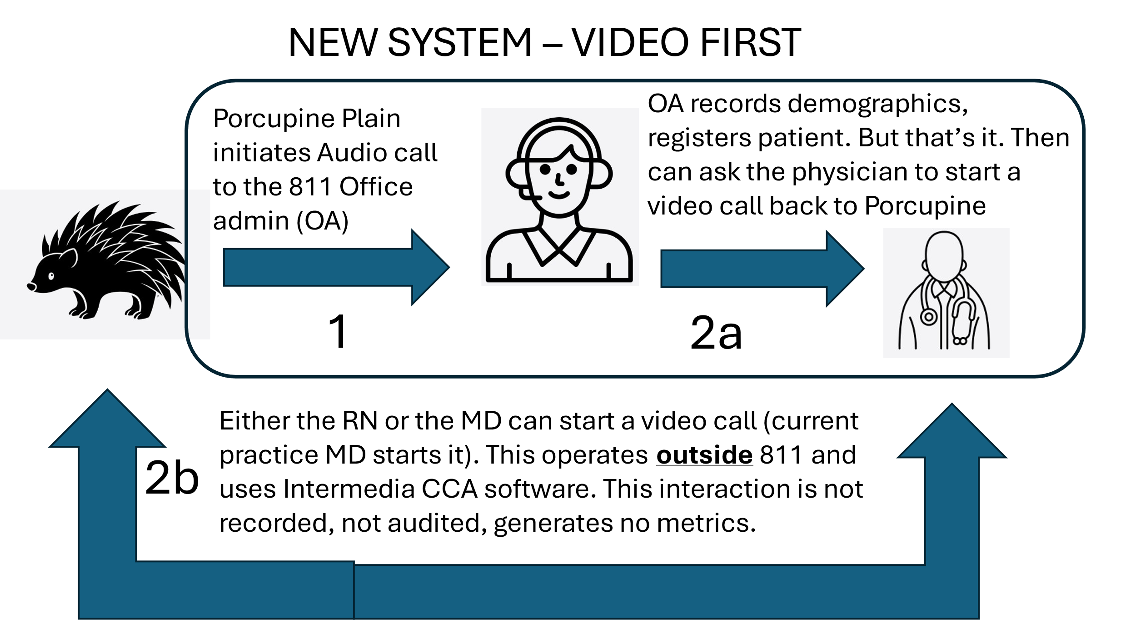

# NEW STATE (Video First)

|  |  |  |
| --- | --- | --- |
|  | Wins | Loss |
| Patients | 1. Patient experience is closer to the ‘real world’. You see your doctor. | 1. Video visits are longer. Physicians may spend longer on other calls increasing wait times. |
| Nurses | 1. Some nurse might feel more comfortable knowing the doctor did a visual assessment of the patient. | 1. Increased wait times to see a physician. 2. No record of calls thus if there are questions about physician orders there is no way to confirm those orders. |
| Physicians | 1. None | 1. Video calls are (in most cases) not at all clinically useful. Looking a patient head does not help with the diagnosis of headache. 2. Privacy is not guaranteed. VIPER physicians can be anywhere (home, kids hockey game, grocery shopping). Thus, video calls would be taken anywhere. 3. Call review and call audits cannot be performed anymore. While audio calls are stored in Intermedia CCA for review for 7 years. 4. Video calls are intrinsically slower. The takt time per physician will go up. The patient per hour throughput of physicians will go down. Specifically on busy day time shifts this will result in longer wait times to be seen / assessed. |
| Healthline | 1. None | 1. All call metrics (call volumes, durations, takt time) uses the Intermedia CCA software. This is audio only. 2. We load balance calls between multiple physicians using Intermedia CCA. For example, 6 sites join a common queue to talk to 2 viper docs. Again, audio only. |